Custom Motor Controller Research

Using the STM32F103 as the micro, TI 8353RS as the gate driver, and using external MOSFETS to drive motor

Connections Diagram: 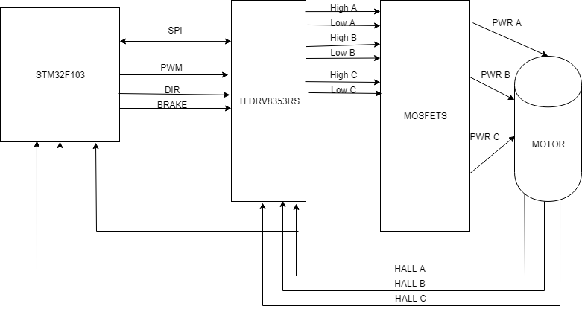

Planning on using 1x PWM Control

Just need to send INHA pin a single PWM signal with duty cycle

Tie INHB, INLB and INLA to Hall effect sensors (INLA = HALL_A, INHB = HALL_B, INLB = HALL_C)

INHC and INLC are tied to GPIO pins on the micro to control direction and braking respectively

We can also feed hall effect sensors to micro itself for closed loop control

Research:

1. Planning on first testing with TI evaluation board

Objective is to drive a motor using only the TI evaluation board and software

2. Planning on using TI evaluation board driver circuit but driving with STM32F401RE Nucleo

Objective is to drive a motor using this system

3. Design PCB with STM32F103 and TI DRV8353RS on single board based on TI eval board

PCB Design:

Will have to make design generic as possible

Will need to place power regulators on every board with jumpers to switch daughter card output power (36V, 24V, 12V)

CAN Protocol -> each board will need to have a CAN transceiver onboard connected to CAN module pins of STM32F103

We will be using PCIe 1x or 4x connector for the Daughter-Mother board connection

Mother board will contain only power regulators, CAN bus, and connectors -> most driving and control functionality is left to daughter card

EMI may pose a threat due to high voltage sources being close to logic circuits -> using the small traces on a PCIe card to conduct motor drive voltage/current may pose an issue

Easiest part: Designing Gate driver circuit -> just use the TI eval board schematics

Hardest part: Integrating the STM32F103 onto the board -> there are schematics, but getting this to work with no issue will be an incredible challenge, plus there is the question of needing to flash the micro with core software

Manufacturing this PCB is probably a no go -> we do not have the resources nor experience to manufacture this ourselves. We need to either get assistance from a University organization or look to a company to populate the board for us

Datasheet to TI DRV835RS: <http://www.ti.com/lit/ds/symlink/drv8353.pdf>